DISC DEXPI additional modelling for ‘show & tell’ 6. December

The purpose of this document is to provide models and document common understanding of elements that are not part of the current DISC DEXPI requirements document but have been found in the additional P&ID drawings provided for the 6. December DISC DEXPI meeting.

Any modelling described below has not been fully discussed within the DISC DEXPI group and is provided as a way to quickly move forward with these element types for the meeting. We will discuss any final modelling of these elements as a group at a later date.

Contents

1. Equipment / Package boxes: 2

2. Mult-reference SI label: 2

3. Low Signal indicator: 3

4. Flow Meter symbol 3

5. CD Reference 4

6. To Drain References 4

## Equipment / Package boxes:

**Challenge**: The Package element/symbol has not been defined, mapped, modelled.

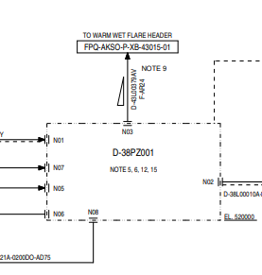

**Response**: The following mapping and symbol identification for package element to be used for 6. December DISC meeting.

|  |  |  |  |  |  |
| --- | --- | --- | --- | --- | --- |
| DEXPI ID | Symbol | DEXPI Class | Class URI | Type Name for Custom Class | Type URI for Custom |
| TMP001 |  | CustomEquipment | http://sandbox.dexpi.org/rdl/CustomEquipment | PACKAGE ASSEMBLY | https://data.posccaesar.org/rdl/RDS1143359 |

This mapping definition allows us to attach nozzles as shown for piping and use relevant nozzle/flange combination to connect signal lines.

## Mult-reference SI label:

**Challenge:** A SI label instance can only be referred to by one class element.

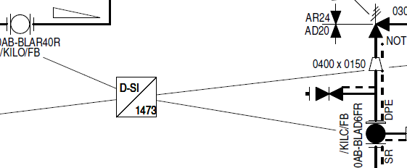

**Response:** Use 4 instance of the SI label symbol with the same placement point. Each label instance will have it own reference point element and lead line.

**Note: Equinor does not allow multiple elements to share the same SI number.

## Low Signal indicator:

**Challenge:** Symbol representing low signal is not modelled or mapped in DISC DEXPI.

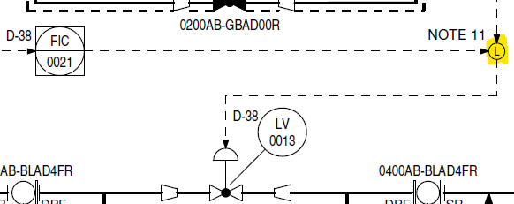

**Response:** Use the [ND0038](https://equinor.github.io/NOAKADEXPI/Symbols/Detail/ND0038_Detail.svg) to represent this symbol and provide the required mapping to ProcessInstrumentFunction and starting/end point for SignalConveyingFunctions.

## Flow Meter symbol

**Challenge:** This specific Flow Meter symbol is not recognized as it is used on the P&ID.

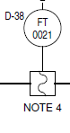

**Response:** Use [PF005A](https://equinor.github.io/NOAKADEXPI/Symbols/Detail/PF005A_Detail.svg) with rotation. The symbol usage is incorrect according to the legend and this should raise an error.

## CD Reference

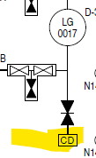

Not relevant for 6. December as this has been replace in later version of the file. Will be discussed at a later date re. How to manage temporary items https://dev.azure.com/EquinorASA/Spine/_workitems/edit/132972

## To Drain References

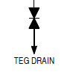

Not relevant for 6. December as this has been replace in later version of the file. Will be discussed at a later date re. How to manage temporary items https://dev.azure.com/EquinorASA/Spine/_workitems/edit/132972